**Calculating Family Expenses using Service Now**

Team ID : NM2025TMID17485

Team Size : 4

Team Leader : Nandhini.D

Team member : Deepika.G

Team member : Sneha.S

Team member : Dhanalaksmi.R

**Problem Statement:**

The project aims to develop a comprehensive expense calculation system using ServiceNow. This system will enable users to track and manage family expenses efficiently. It will include features such as expense categorization, budget setting, real-time tracking, and reporting capabilities. Utilizing ServiceNow's robust platform, the project will ensure seamless integration, user-friendly interface, and scalability to accommodate varying family sizes and financial complexities. The end goal is to empower users with the tools they need to make informed financial decisions and promote financial well-being within the family unit.

**Objective:**

**SKILLS:**

IOT Open Hardware platforms,Data Structures

**TASK INITIATION**

**Milestone 1 : Setting up ServiceNow Instance**

**Activity 1: Setting up ServiceNow Instance**

1. Sign up for a developer account on the ServiceNow Developer site “https://developer.servicenow.com”.
2. Once logged in, navigate to the "Personal Developer Instance" section.
3. Click on "Request Instance" to create a new ServiceNow instance.
4. Fill out the required information and submit the request.
5. You'll receive an email with the instance details once it's ready.
6. Log in to your ServiceNow instance using the provided credentials.
7. Now you will navigate to the ServiceNow.

**Milestone 2 : Creation of New Update Set**

**Activity 1: Creation of New Update Set**

1. Go to All >> In the filter search for Local Update set > click on New.

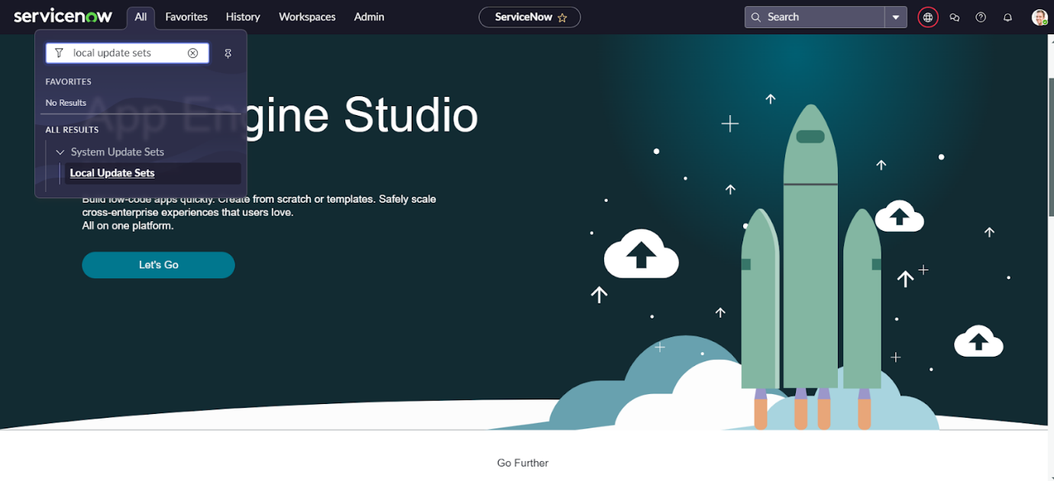

1. Enter the Details as:

Name : Family Expenses

1. Then click on Submit and Make current.

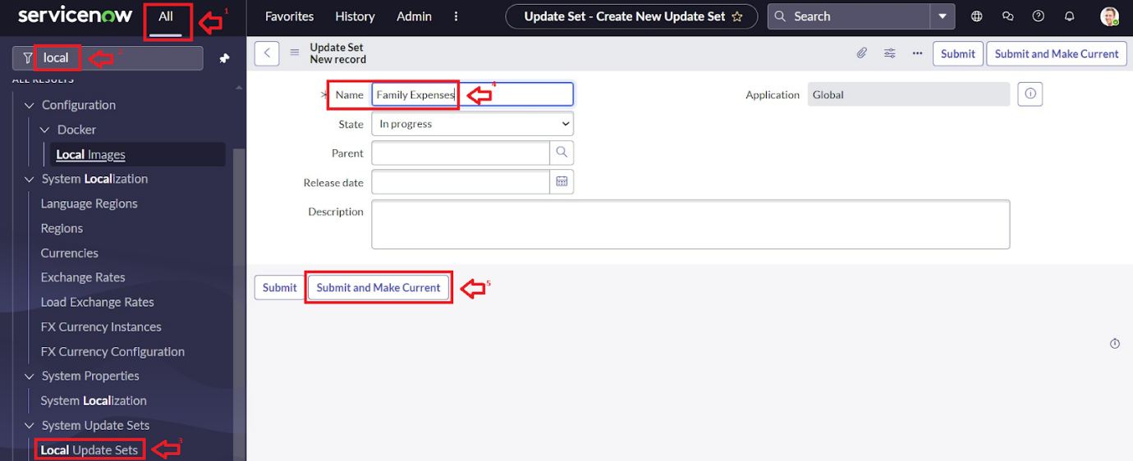

**Milestone 3 : Creation of Table**

**Activity 1: Creation of Table**

1. Go to All >> In the filter search for Local Update set > click on New.



1. Enter the Details as:

Name : Family Expenses

1. Then click on Submit and Make current.

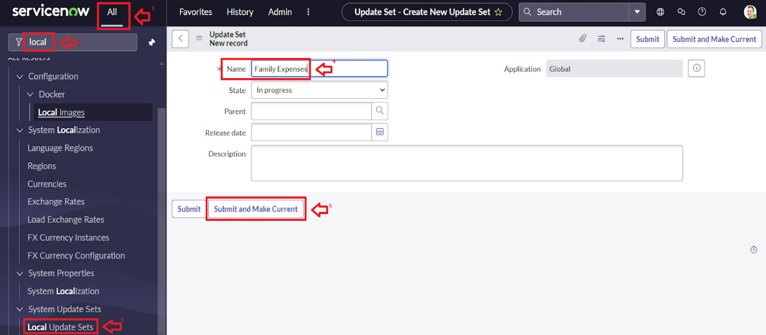

**Milestone 3 : Creation of Table**

**Activity 1: Creation of Family Expenses Table**

1. Go to All > In the filter search for Tables > click on New.
2. Enter the Details:

Label : Family Expenses

Name : Auto-Populated

New menu name : Family Expenditure

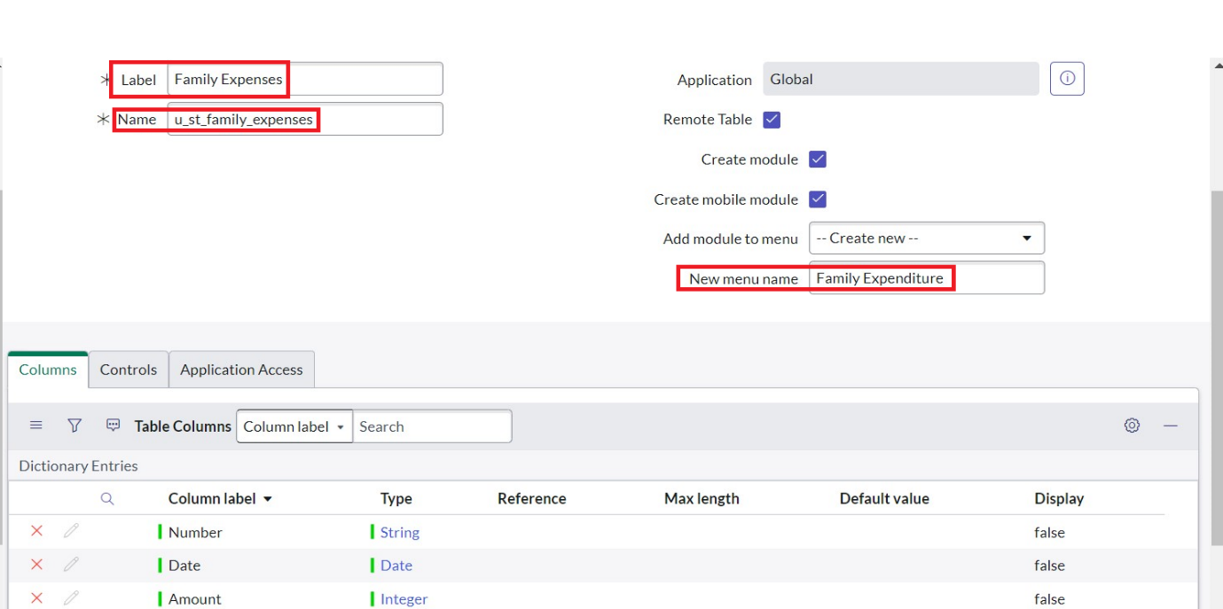

1. Go to the Header and right click there>> click on Save.

**Activity 2: Creation of Columns(Fields)**

1. Near Columns Double click near insert a new row.
2. Give the details as:

Column label : Number

Type : String

1. Double click on insert a new row again
2. Give the details as:

Column label : Date

Type : Date

1. Double click on insert a new row again
2. Give the details as:

Column label : Amount

Type : Integer

1. Double click on insert a new row again
2. Give the details as:

Column label : Expense Details

Type : String

Max length : 800

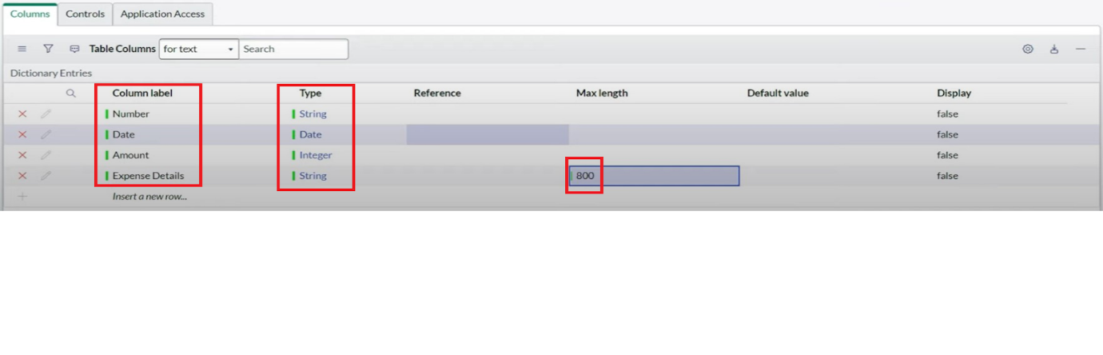

1. Go to the Header and right click there>> click on Save.

**Activity 3: Making Number Field an Auto-Number**

1. Double click on the Number Field/Column.
2. Go down and double click on Advanced view
3. In Default Value:

Use dynamic default : check the box

Dynamic default value : Get Next Padded Number

1. Click on Update.

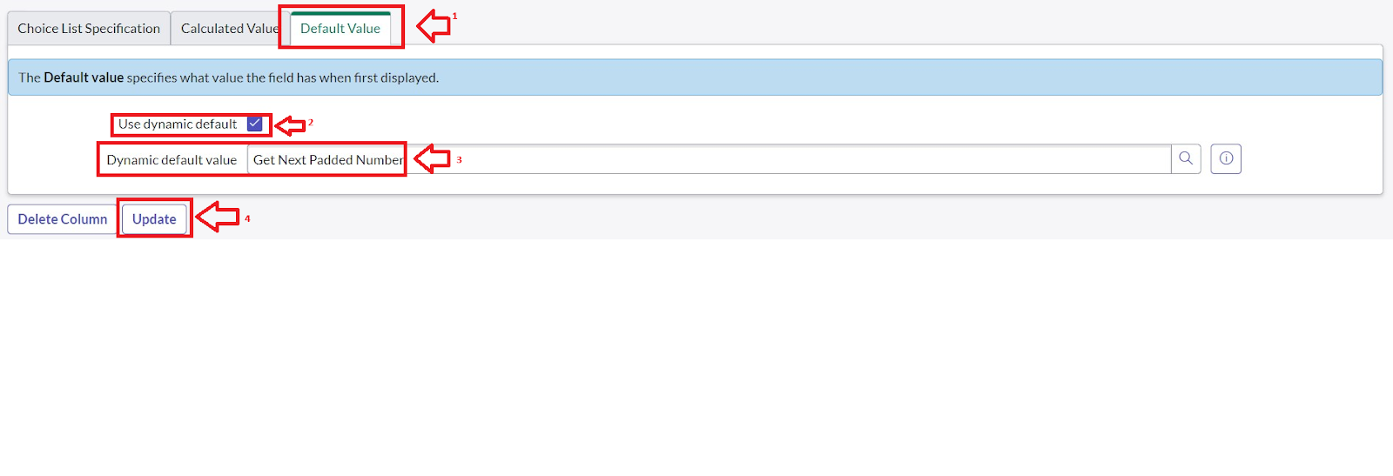

1. Go to All >> In the filter search for Number Maintenance >> select Number Maintenance
2. Click on New.
3. Enter the below Details:

Table : Family Expenses

Prefix : MFE

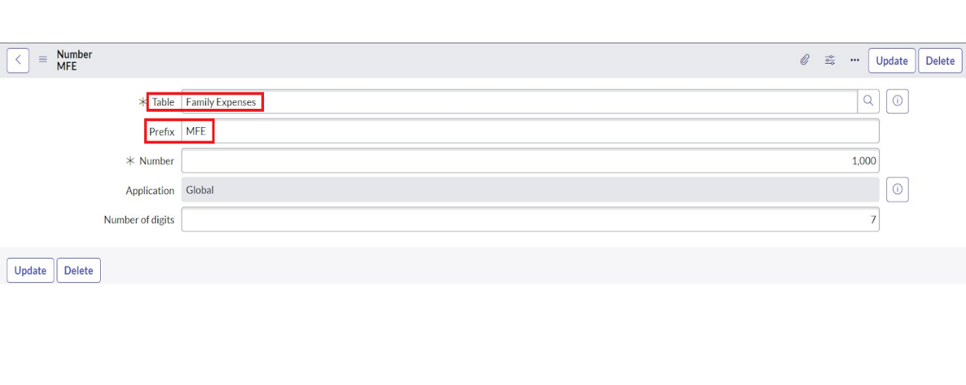

1. Click on Submit.

**Activity 4: Configure the Form**

1. Go to All >> In the filter search for Family Expenses >> Open Family Expenses
2. Click on New
3. Go to the Header and right click there>> click on Configure >> Select Form Design
4. Customize or Drag Drop the form as per your requirement.

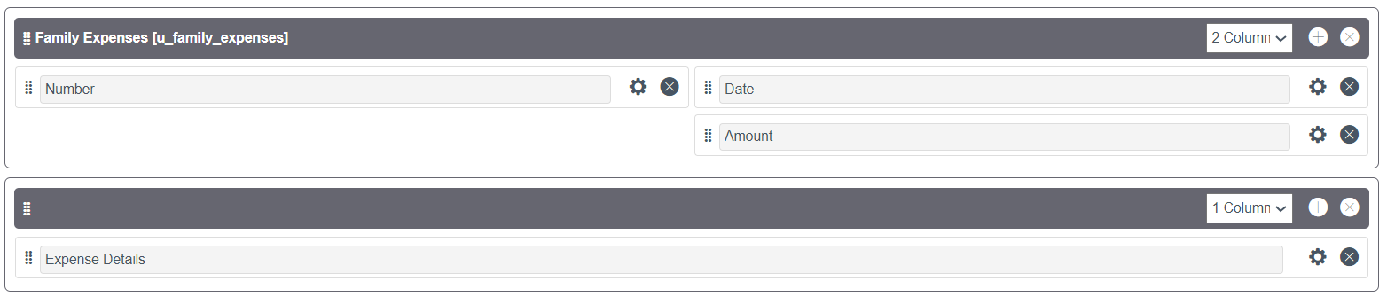

1. Make Number Read-Only Field by clicking on the gear icon and checking Read-Only
2. Make Date, Amount Mandatory Field by clicking on the gear icon and checking Mandatory
3. Click on Save.